

FortnaPlus Control
Start Stop Zones
Start Stop Zones
Document Revision: 1.2
Date: 14-Jan-2021

Revision | Date | Author | Revision Summary
1.0 | 16-Mar-2016 | B C Conklin | New document
1.1 | 09-Jul-2020 | T R Kremser | Updates and general refresh
1.2 | 14-Jan-2021 | T R Kremser | Add Start/Stop examples

Table of Contents
1. Start/Stop Zones 4
2. Configuring Start/Stop Zones 5
3. Disabling Start/Stop Zones 6
4. Start/Stop Zone Security 7
5. The StartStopZones Table 7
6. The Jamzones Table 7
7. The Jamcheck Table (Jam Detection) 9
8. Combined Jam Zones 11
9. Zone States 13
10. The Start/Stop Window 14
10.1. Example Start/Stop Status Screenshots 15

Confidential/Proprietary Statement
This document contains trade secrets and information that is considered confidential and proprietary to Fortna, Inc. It may not be duplicated, used, or disclosed outside the original recipient organization, and it may not be duplicated, in whole or in part, for any purpose other than to evaluate this document. Fortna Material Handling reserves the right to modify this document as necessary to reflect any terms and conditions negotiated and included as part of a subsequent contract or purchase order.

Start/Stop Zones
Start/Stop Zones are configured in table StartStopZones to define functional areas of a conveyor system that the user will start and stop together. Start/Stop Zones can have one or more jam zones.
Typical Start/Stop Zones:
- Receiving
- Picking
- Print Apply
- Shipping
Jam zones are configured in table Jamzones to define sections of conveyor that will stop together if a jam occurs.
Each jam zone requires an Enable Bit to define when all conditions are met to allow the zone to run. There may be many individual inputs that define the enable conditions, including E-Stops, Air Pressure indicators, Interlocks, and other inputs. The CombinedJamZones and CombinedEnableBits tables can be used to make it easier to gather all the enable conditions into a single enable signal.
Each jam zone requires input signals to indicate jams. These are defined in table Jamcheck. Any number of input devices (usually photo eyes – a.k.a., Jam Eyes) can be defined there and linked to a Jamzones entry via the Zones column in table Jamcheck. In addition, a memory bit can be added to the Jammed Bit column of the Jamzones table to indicate directly to another module that a jam zone is in a “jammed” state.
Jamzones are tied to “Motor Startup Chains” (table Mtrchain) by use of a memory bit called a “Latch Bit”. The Jamzones_Latch Bit is used to link the jam zone entry to the motor chain entry in Mtrchain_Motor_Aux to define the beginning of the motor chain. When the jam zone is successfully started, the Latch Bit will be set, allowing the first motor to start, and initiating the startup chain. A similar concept can also be used to stop an entire jam zone by selecting it in the Mtrchain_Stop Zone column. This allows a motor overload error to signal that a stop is needed.

Configuring Start/Stop Zones
Define the following to set up the conditions for a start/stop zone to start and to detect jams.
- Create a memory bit to use as the “Enable Bit” and use it to link Jamzones_Enable Bit and CombinedJamZones_JamEnableCombined. See the section on Combined Jam Zones for detail.
- In the Jamzones table, select a memory bit in column Latch Bit. Select the same memory bit in table Mtrchain column Motor_Aux. The Latch Bit is the output of the jam zone and serves as the first “motor” input to initiate the motor chain.
- Create a timer for Jamzones_Start Stop Timer. It will be used to limit how often the zone may be started, as a sort of “debounce” for physical pushbuttons or the on-screen buttons. This helps protect the hardware from spurious inputs.
- If needed, create a memory bit for Jamzones_Jammed Bit. This bit will be set by the software to indicate that the jam zone is in a jammed state and can be used as an output to signal other modules. [The bit is also fired if a power supply signal goes OFF.]
The software uses the list of Jam Zones to create the “Start/Stop Window”. Each jam zone is represented in the “Start/Stop Window” by a small square box beneath the status line for each Start/Stop zone. The state of the jam zone is indicated by the color and in the description found in the second column displayed for each line. Refer to the section on Zone States, below, for details on the information displayed.

Disabling Start/Stop Zones
By default, all Start/Stop Zones can be controlled from the Start/Stop Window on any Automation Controller. In some applications, it is desirable or required that certain zones be accessible only from the Automation Controller in closest physical proximity to the zone.
Option 1 – Older Systems that do not have the StartOwnerCtl column in the StartStopZones table.
- The Start request is sent to other nodes if the Jamzones_Latch Bit is OFF, and the Jamzones Enable Bit is ON.
- The Stop request is sent to other nodes if the Jamzones_Latch Bit is ON.
It is always desirable, for safety, to allow anyone to stop a zone. If you want to disable sending the Start request but continue to send the Stop request, change the Jamzones_Enable Bit to be the “NEVERON” part on the nodes where the Start request is to be disabled.
Option 2 – Newer Systems with the StartOwnerCtl column in the StartStopZones table.
- The Start request is sent to other nodes if the StartOwnerCtl column is NOT selected in the StartStopZones table.
  - If the jam zone is “owned” by the Automation Controller (set the owner in Jamzones_Zone Owner), the Start request is sent to other nodes regardless of the status of StartOwnerCtl.
- The Start request is NOT sent to other nodes if the StartOwnerCtl column is selected in the StartStopZones table.

- The Stop request is sent to other nodes if the StopOwnerCtl column is NOT selected in the StartStopZones table.
  - If the jam zone is “owned” by the Automation Controller (set the owner in Jamzones_Zone Owner), the Stop request is sent to other nodes regardless of the status of StoptOwnerCtl.
- The Stop request is NOT sent to other nodes if the StartOwnerCtl column is selected in the StartStopZones table. It is always desirable, for safety, to allow anyone to stop a zone.
Using these features will make the Jamzones configuration unique for each node. Do not distribute the Start/Stop configuration to all nodes.

Start/Stop Zone Security
Start/Stop Zone security is controlled by the security settings of the following two functions found in Administration Menu | Set Security Levels:
      - Startstop – Controls a user’s ability to open the Start/Stop Window.
      - Startstop Security – Controls a user’s ability to access the Start All button on the main menu bar. The Stop All button on the main menu bar is always accessible, for safety.
Double-click the Security_Level field to open the Role Editor window. Select roles that will be allowed to access each item. If the user’s privileges overlap the item’s privileges on at least one role, access will be granted. If no roles are selected (field value of zero), access is granted to all users.

The StartStopZones Table
The StartStopZones table defines sections of the conveyor that will be started and stopped by the user as one unit. Each start/stop zone entry can be linked to multiple jam zones. Usually, all the hardware in a start/stop zone is controlled by a single control panel. The name of the start stop zone is displayed in the Start/Stop Window along with the state of the zone.
StartStopZones Table
FIELD | DESCRIPTION
Zone Name | Choose a unique name for the start/stop zone. This name will be displayed in the Stop/Start Window.
StartReqFlag | Controlled by the software. Indicates a start request has been made.
StopReqFlag | Controlled by the software. Indicates a stop request has been made.
State | Controlled by the software. Indicates the current state of the zone.
WasState | Controlled by the software. Indicates the previous state of the zone.
StartOwnerCtl | Determines which ACs can start a zone. See Disabling Start/Stop Zones
StopOwnerCtl | Determines which ACs can stop a zone. See Disabling Start/Stop Zones

The Jamzones Table
The Jamzones table contains a list of jam zones or areas of a conveyor to operate together as a unit. All the equipment in a jam zone will stop together when a jam is detected, or an E-Stop is activated.
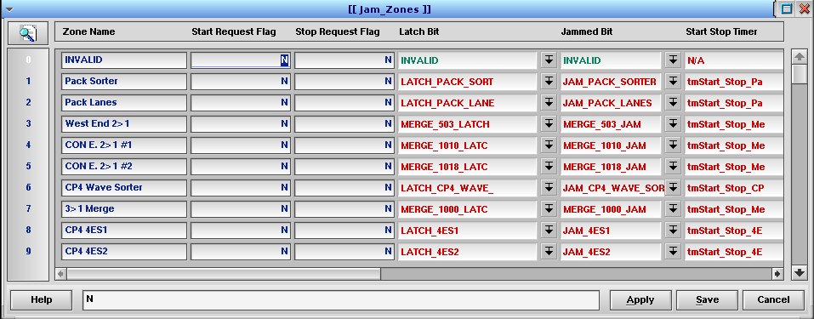

Jamzones Table
FIELD | TYPE | DESCRIPTION
Zone Name | String | Choose a unique identifier for the jam zone.
Start Request Flag | Y/N | Used by the software to initiate a “Start Request” for the jam zone. Messages are sent to all the other Automation Controllers defined in the Machine table for the same jam zone. When a “Start Request” is processed, any active jams are reset.
Stop Request Flag | Y/N | Used by the software to initiate a “Stop Request” for the jam zone.
Latch Bit | PopUp | Select a memory bit from the Conveyor table to control this zone. The state of this bit indicates if the zone is running or stopped. The machine that owns the jam zone will turn the bit ON or OFF if the jam zone is being started through the Request Flag, or if the Jammed Bit is OFF and the Enable Bit is ON.
Jammed Bit | PopUp | Select a memory bit from the Conveyor table to indicate a jam on this zone. The software will turn this bit ON or OFF to reflect the jam state of the zone. The bit is also fired if a Power Supply Signal goes OFF.
Start Stop Timer | PopUp | Select the timer that will be used to delay successive starts of the zone. The timer is used to debounce the buttons. The timer is required for each Jam Zone.
Zone Owner | PopUp | Select the machine controlling the zone. Only the machine that owns the jam zone sends “Start Request” events to other machines.
Enable Bit | PopUp | Select the memory bit that has been created and named for this zone. It indicates if the zone can be started.
Start Button | PopUp | Select the part that represents the start pushbutton on the panel. The “Start Button” initiates a “Start Request”.
Stop Button | PopUp | Select the part that represents the stop pushbutton on the panel. The “Stop Button” initiates a “Stop Request”.
Reset Button | PopUp | Select the part that represents a reset pushbutton on the panel. The “Reset Button” will activate a “Start Request” if the Jammed Bit is ON.
StartStopZone | PopUp | Select the associated start/stop zone from the StartStopZones table that controls this jam zone. Start events from the Start/Stop Window (button clicks) will be directed to the Jamzones table entries associated with the start/stop zone.
JamEnableDontDelay | Y/N | Choose Y to act upon “Start Request” events immediately. In other words, to skip the Start Stop Timer in the start/stop sequence.  This feature was added in Version 10.95 when the Start Stop Timer was included in the start stop sequence. Prior versions did not include the timer in the start stop sequence when a jam or loss of enable caused the zone to stop, so to duplicate the older behavior, set this field to Y.

The Jamcheck Table (Jam Detection)
The Jamcheck table is used to control detection of conveyor jams, to update the colors of the jammed conveyor on-screen, and to trigger jam errors.
The Jamcheck table is used to configure inputs, usually from photo eyes, that will detect when a jam occurs. When a jam is detected, the resulting error causes the jam zone to stop.
Jam photo eyes are selected in the column Sensor_Name. When the photo eye becomes blocked the timer in the column Timer_Name begins timing. If the timer runs to completion, an Error is triggered. Timers used for jam detection are prefixed with “tm” and include the name of the photo eye, usually ending with “_J” for jam.
Note: A jam timer will only “run” if the motor that is under the photo eye is running. If the conveyor is stopped the timer will not run, even if product is blocking the jam eye.
The Timer_Preset column is used to set the amount of time that the photo eye must be blocked to detect a jam. The value can easily be adjusted by typing in a new value, in seconds. The new value will take effect as soon as the Apply button is clicked.
Each Jamcheck entry is connected to an error (defined in the Errors table) using the Error_Name column. The error is latched ON when a jam occurs and will remain ON until the start sequence is activated.
- A Jam can be configured to clear automatically when the start sequence is initiated by selecting the associated start/stop zone in Jamcheck_Zone.
- Alternatively, a jam can be configured to clear when a pushbutton is pressed. Select the pushbutton in Jamcheck_ClearJamSignal and leave Jamcheck_Zone set to INVALID to activate this option.
- A third option is the “Jam Reset L2” feature. A user with Maintenance privilege must clear the jam by selecting “Jam Reset L2” from the “Reset Utilities” option on the Maintenance menu. To activate this option, set Jamcheck_RequireL2Reset = Y.
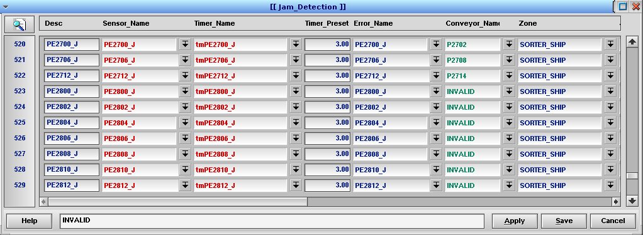

Jamcheck Table
FIELD | TYPE | DESCRIPTION
Desc | String | Enter a unique name.
Sensor_Name | PopUp | Select the part name of the jam sensor. The sensor may be a photo eye, a contact from a piece of equipment, or other device that provides an input signal.
Timer_Name | PopUp | Select the name of the jam detection timer located in the timer table.
Timer_Preset | Float | Set the length of time for the timer to run before a jam is declared and the motor stops.
Error_Name | PopUp | Select the name of the error from the Errors table to fire when a jam is detected.
Conveyor_Name | PopUp | Select the name of the part to draw in a jammed state on the GUI display when a jam is detected.
Zone | PopUp | Select the jam zone associated with this entry (link to the Jamzones table).
Jam_Owner | PopUp | Select the machine controlling the jam zone.
Jam_State | Int | The software updates this value to indicate the state of the jam.
Motor Under Jam Eye | PopUp | Select the motor that must be running for the timer to time.
Sent | Int | The software updates this value to indicate if the jam state was sent to other automation controllers.
ClearErrorWithJam | Y/N | Set to N if the jam error is to remain on until the “Start” sequence is run. Set to Y to clear the error as soon as the jam clears (This is used in cases where the jam state does not need to be held until the Start Sequence for the zone is initiated).
ClearJamSignal | PopUp | If needed, select a signal that will be used to clear the jam.
RequireL2Reset | Y/N | Set to N if the jam will be cleared when the “Start” sequence is initiated for the Zone (this is the normal way). Set to Y to require that the “Jam Reset L2” function be used to clear a jam (The function is found in the Maintenance Menu | Reset Utilities).
L2_Jam_State | Int | Set by the software to indicate the status of the Jam Reset L2 feature.
L2_ClearJamSignal | PopUp | This input may be used to initiate a jam reset in addition to the “Jam Reset L2” menu option, perhaps using a key switch.

Combined Jam Zones
Often, many inputs must be considered to determine if a jam zone is ready to run. The Jamzones_Enable Bit is used to indicate the overall state and tell the software that the zone can be started. It is usually defined as a memory bit that represents a logical AND of all the input states. The CombinedJamZones and CombinedEnableBits tables make it easy to combine many inputs.
Input signals may include: E-Stop signals, air pressure signals, interlock signals, and the main control relay (MCR) input.
Define one row in the CombinedJamZones table for each combined output you need. Link it to the Jamzones_Enable Bit using the JamEnableCombined field. Define one row in the CombinedEnableBits table for each input signal you have. Set each input signal in the JamEnableBit column and connect it to the CombinedJamZones table by selecting its row in CombinedEnableBits_CombinedJamZones. You can invert the input signals using the InvertJamBit column to produce AND NOT logic, if needed.

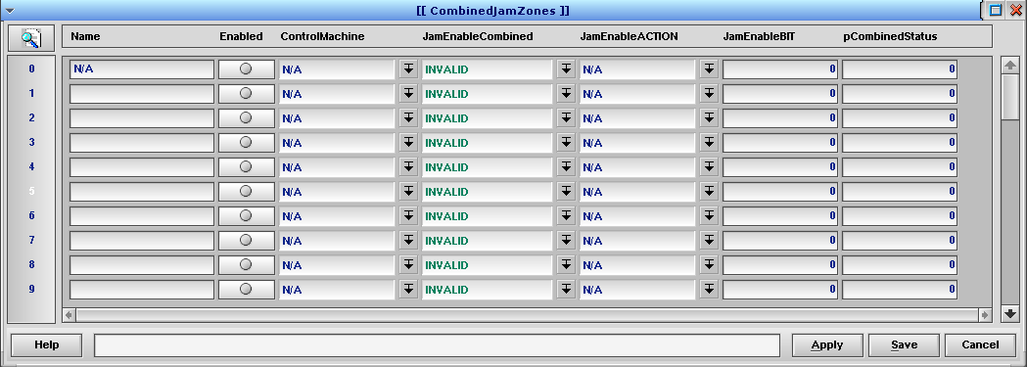

CombinedJamZones Table
FIELD | TYPE | DESCRIPTION
Name | String | Enter a unique name for the combined input.
Enabled | Radio | This field allows the entire entry to be manually turned on or off. If it is enabled, the software will check each bit linked from the CombinedEnableBits table. If the entry is not enabled, the JamEnableCombined output will be turned OFF.
ControlMachine | PopUp | Select the machine that will control the output.
JamEnableCombined | PopUp | Select the memory bit that will serve as the combined output.
JamEnableACTION | PopUp | Select the action that will be used to turn the output ON or OFF.
JamEnableBit | Int | If JamEnableACTION is set to Enable or Disable, enter the bit to use.
pCombinedStatus | Int | Used by the software in computation of the combined state of the inputs.

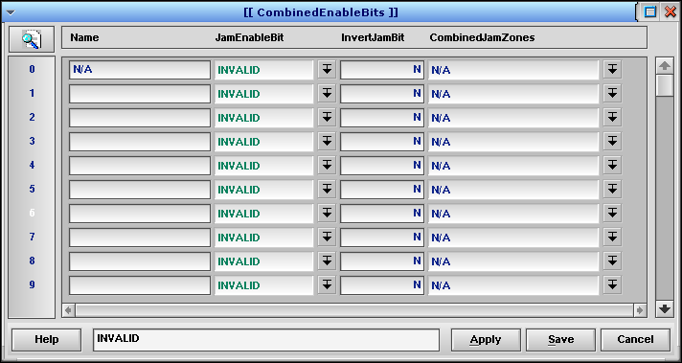
CombinedEnableBits Table
FIELD | TYPE | DESCRIPTION
Name | String | Enter a unique name for the enable bit.
JamEnableBit | PopUp | Select an input signal to check.
InvertJamBit | Y/N | Set the ‘sense’ of the input signal. Enter N to consider the JamEnableBit ON when it is turned ON. Enter Y to invert the logic and consider the JamEnableBit ON when it is turned OFF.
CombinedJamZones | PopUp | Select the CombinedJamZones row to associate with this entry.

Zone States
These are the possible states that can appear in the Start/Stop Window, and their meanings.
STATE | DESCRIPTION
0 | Invalid
1 | Not_Enabled
2 | Stopped
3 | Starting
4 | Running
5 | Stopped
6 | Jammed
7 | One_Not_Enabled
8 | One_Stopped
9 | One_Starting
10 | One_Running
11 | One_Stopping
12 | One_Jammed

- The software processes the Jamzones states in the following order:
- If Jamzones_Enable Bit is OFF, the zone is set to One_Not_Enabled.
- If Jamzones_Stop Request Flag is ON, the zone is set to One_Stopping.
- If Jamzones_Start Request Flag is ON, the zone is set to One_Starting.
- If Jamzones_Jammed Bit is ON, the zone is set to One_Jammed.
- If Jamzones_Latch Bit is OFF, the zone is set to One_Stopped.
- If Jamzones_Latch Bit is ON, the zone is set to One_Running.
- If any of the zones are in a One_Jammed state, the state of the start/stop zone is set to Jammed.
- If none of the zones are jammed, then the start/stop zone is set to state of the first jam zone.
- If all the jam zones in a start/stop zone are in the same state, the software will set the start/stop zone state to one of the following:
1 – Not_Enabled
2 – Stopped
3 – Starting
4 – Running
5 – Stopped
6 – Jammed

The Start/Stop Window
The Start/Stop Window is accessed using START/STOP from the main menu bar. It provides an easy way to start and stop individual start/stop zones or the entire system, and to see the operational state of those start/stop zones and the individual jam zones that they contain.
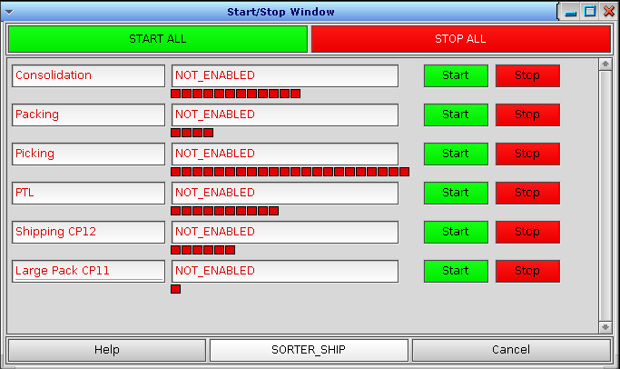
S/S Zone Status
Jam zone Status
Jam zone Name
Start/Stop Zone

The large START ALL and STOP ALL buttons at the top of the window (and the equivalent buttons on the main screen) start and stop the entire system, as you would expect. Individual start/stop zones can be started and stopped using the Start and Stop buttons by each zone name. See the section on Start/Stop Zone Security, above, for details.
The text box in the middle of each start/stop zone line (labeled S/S Zone Status in the image above) shows the overall status of that zone. The meanings of the status messages are described in the first table, below. The row of small boxes beneath each start/stop zone status (labeled Jam zone Status) represent each jam zone. Hover over a jam zone box to see its name in the message box at the bottom edge of the window (labeled Jam zone Name). The color of each jam zone box reveals the status of that jam zone, according to the second table shown below.

Start/Stop Zone Status Text
Status | DESCRIPTION
INVALID | Invalid
NOT_ENABLED | The Enable Bit is OFF in all jam zones
STOPPED | The jam zone is enabled, but not running
STARTING | The jam zone is starting
RUNNING | The jam zone is running
STOPPED | Stopped
JAMMED | The jam zone is in a jammed state
ONE_NOT_ENABLED | One jam zone is not enabled
ONE_STOPPED | One jam zone is stopped. The jam or enable that had stopped the zone has cleared
ONE_STARTING | One jam zone is starting
ONE_RUNNING | One jam zone is running
ONE_STOPPING | One jam zone is stopping
ONE_JAMMED | One of the jam zones is in a jammed state

Jamzone Status Text
Color | DESCRIPTION
Red | The jam zone Enable Bit is not ON. This typically indicates that one of the signals needed for the jam zone is not ON. An E-Stop, air pressure indicator, or interlock signal is NOT ON. The signals needed for the Enable are typically found in the CombinedJamZones table.
Yellow | The jam zone has at least one active jam.
Gray | The jam zone Enable Bit is ON, but the jam zone is not running.
Green | The jam zone is running.

Example Start/Stop Status Screenshots
In the following examples, Testline has three jamzones. The appearance for various situations is show. Note the text in the Start/Stop Zone text box and the colors of the jamzone boxes below it.

All three jamzones are stopped, but they are not disabled or jammed:
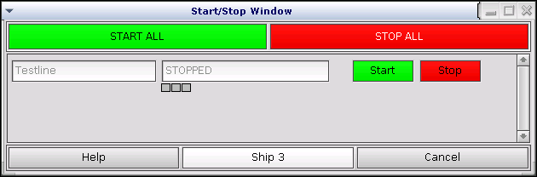

One jamzone is not enabled. The other two jamzones are stopped but are not jammed or disabled:
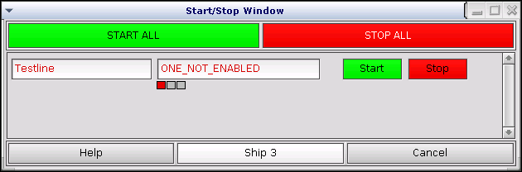

One jamzone is jammed. The other two jamzones are stopped but not jammed or disabled:
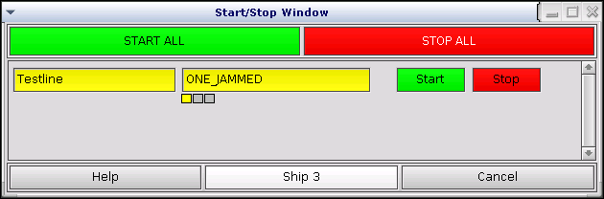

All three jamzones are running:
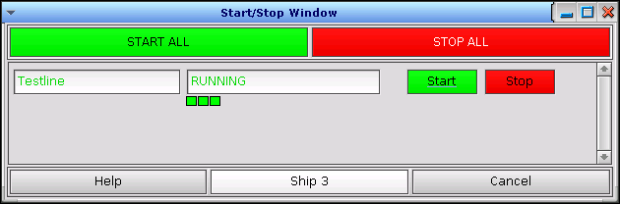

One of three jamzones has stopped, the other two are running. The jam or enable that had caused the stop has cleared:
